**Name: E. Sai Manoj Mis. No.: 112015044**

**Input:**

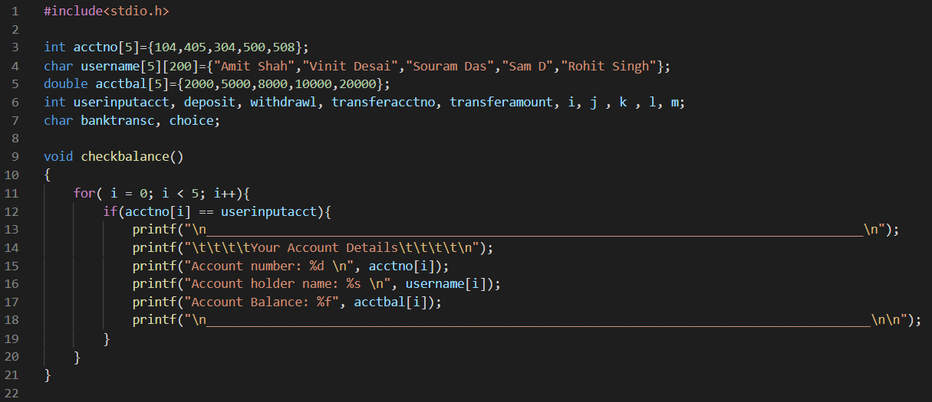

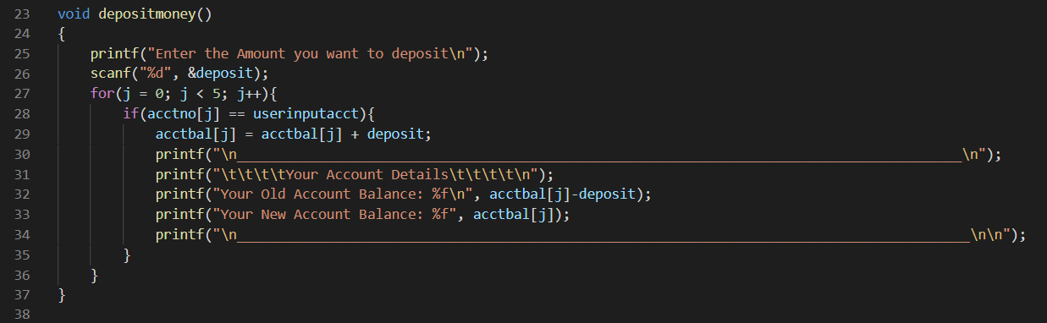

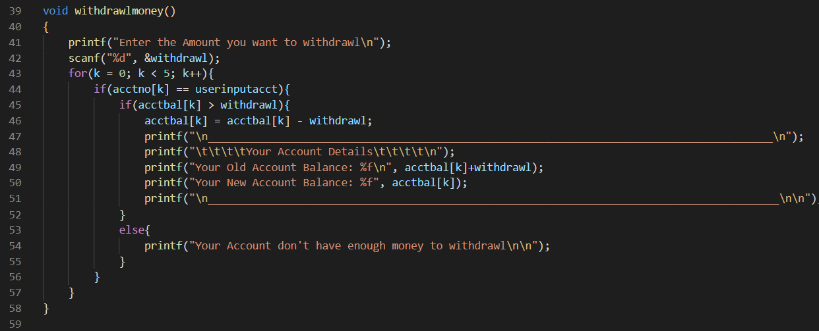

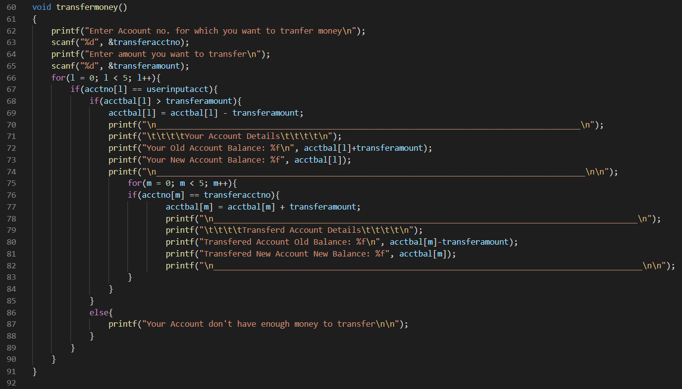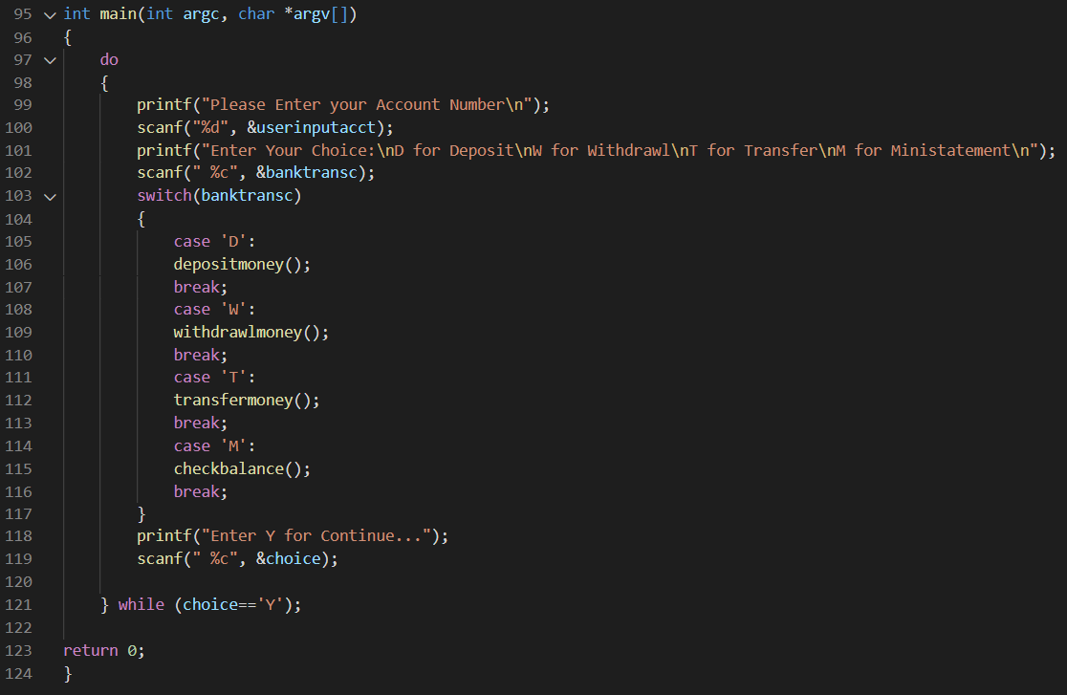

**Output:**

**1)for mini-statement:**

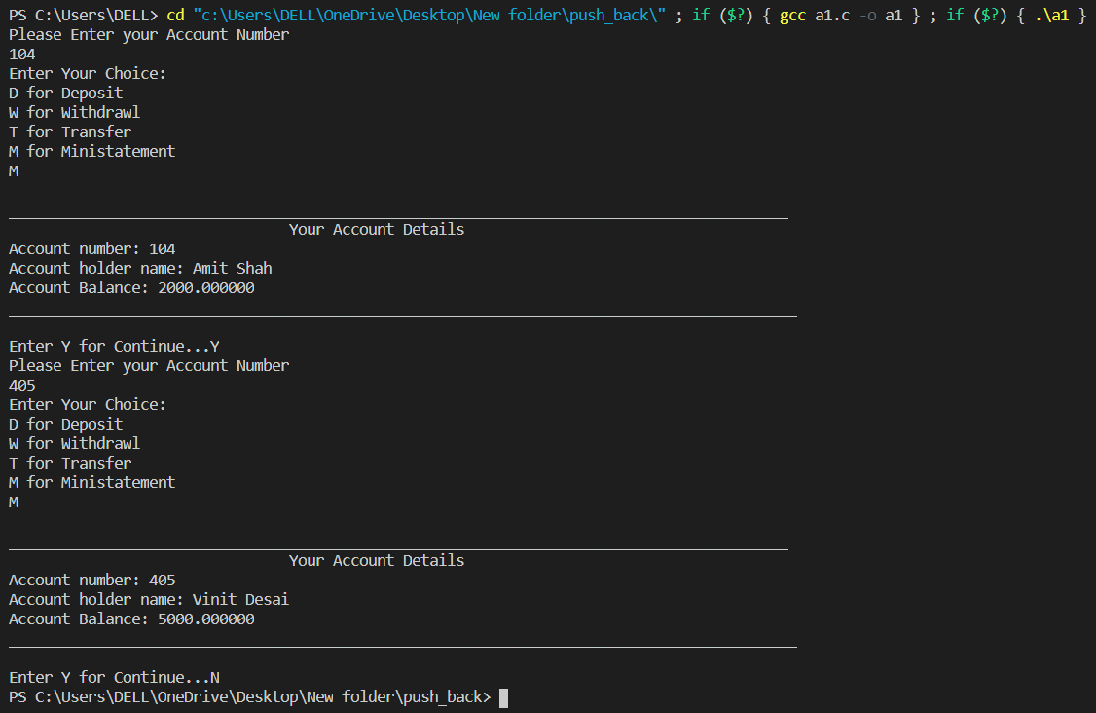

**2)for deposit:**

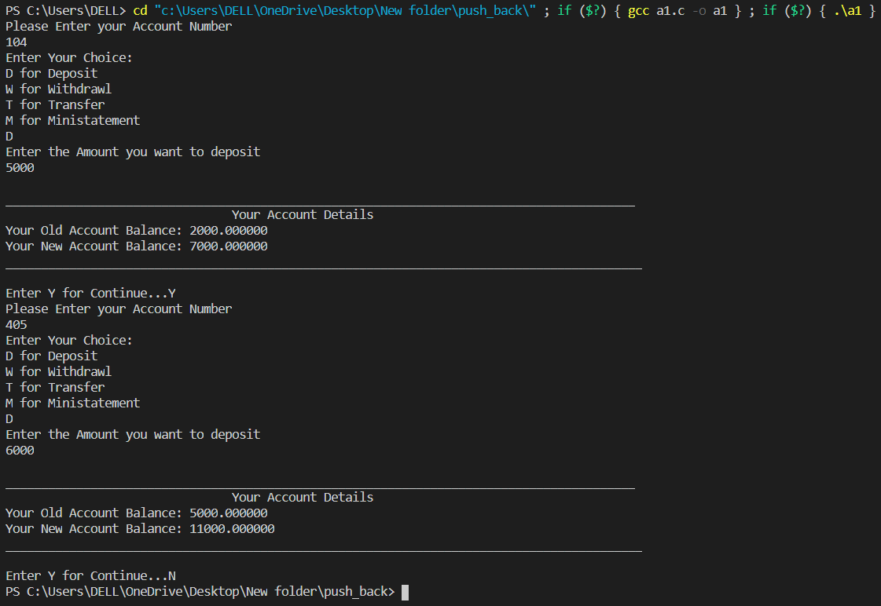

**3) for withdrawl:**

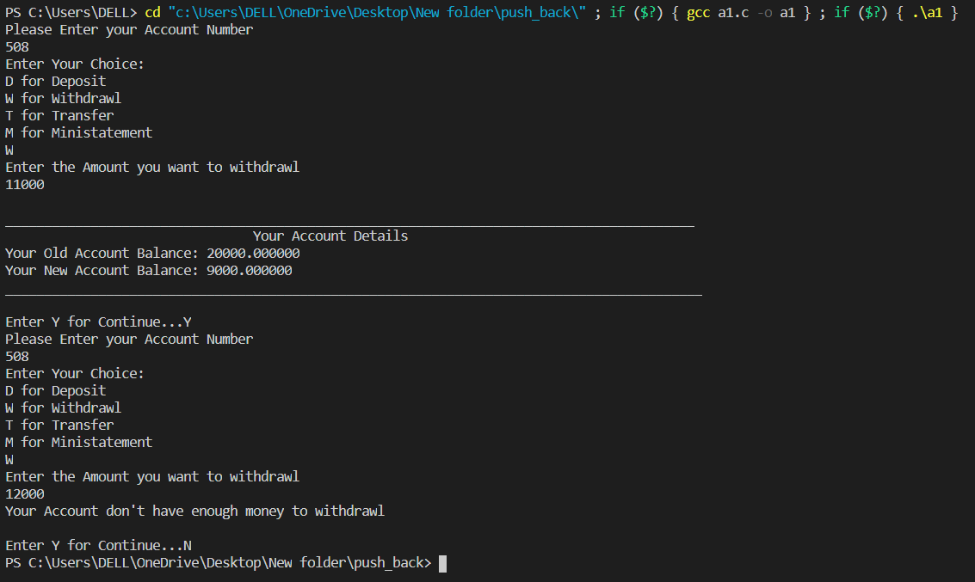

**4) for transfer:**

**a) enough balance:**

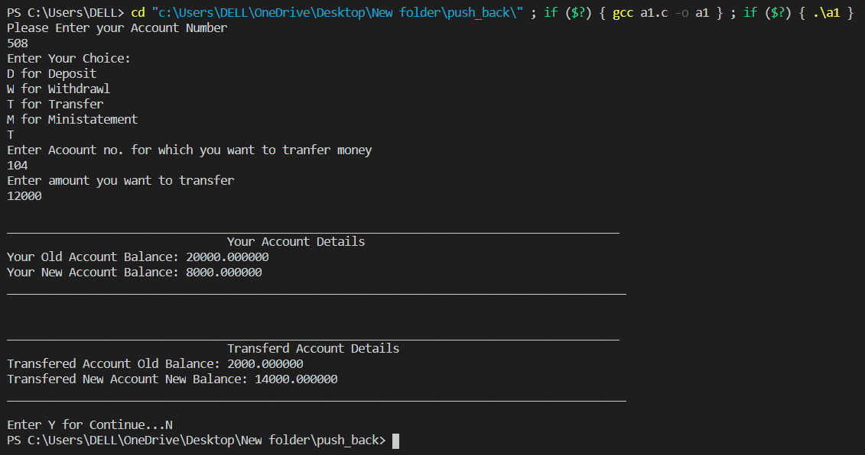

**b) no enough balance:**

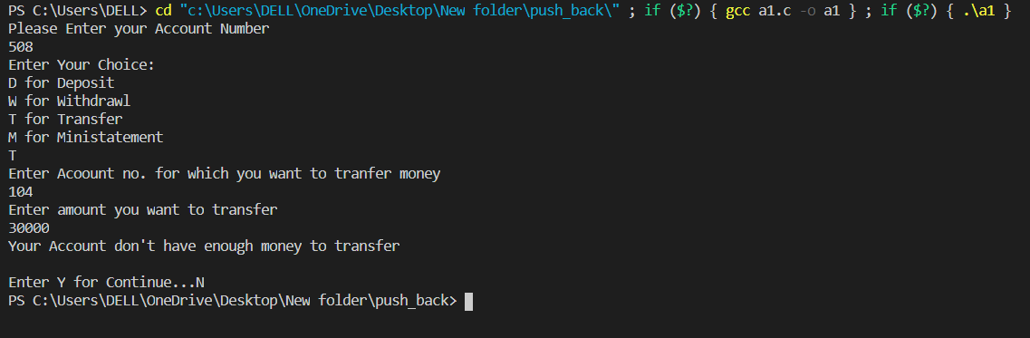

**CODE:**

#include<stdio.h>

int acctno[5]={104,405,304,500,508};

char username[5][200]={"Amit Shah","Vinit Desai","Souram Das","Sam D","Rohit Singh"};

double acctbal[5]={2000,5000,8000,10000,20000};

int userinputacct, deposit, withdrawl, transferacctno, transferamount, i, j , k , l, m;

char banktransc, choice;

void checkbalance()

{

for( i = 0; i < 5; i++){

if(acctno[i] == userinputacct){

printf("\n_________________________________________________________________________________________\n");

printf("\t\t\t\tYour Account Details\t\t\t\t\n");

printf("Account number: %d \n", acctno[i]);

printf("Account holder name: %s \n", username[i]);

printf("Account Balance: %f", acctbal[i]);

printf("\n__________________________________________________________________________________________\n\n");

}

}

}

void depositmoney()

{

printf("Enter the Amount you want to deposit\n");

scanf("%d", &deposit);

for(j = 0; j < 5; j++){

if(acctno[j] == userinputacct){

acctbal[j] = acctbal[j] + deposit;

printf("\n_________________________________________________________________________________________\n");

printf("\t\t\t\tYour Account Details\t\t\t\t\n");

printf("Your Old Account Balance: %f\n", acctbal[j]-deposit);

printf("Your New Account Balance: %f", acctbal[j]);

printf("\n__________________________________________________________________________________________\n\n");

}

}

}

void withdrawlmoney()

{

printf("Enter the Amount you want to withdrawl\n");

scanf("%d", &withdrawl);

for(k = 0; k < 5; k++){

if(acctno[k] == userinputacct){

if(acctbal[k] > withdrawl){

acctbal[k] = acctbal[k] - withdrawl;

printf("\n_________________________________________________________________________________________\n");

printf("\t\t\t\tYour Account Details\t\t\t\t\n");

printf("Your Old Account Balance: %f\n", acctbal[k]+withdrawl);

printf("Your New Account Balance: %f", acctbal[k]);

printf("\n__________________________________________________________________________________________\n\n");

}

else{

printf("Your Account don't have enough money to withdrawl\n\n");

}

}

}

}

void transfermoney()

{

printf("Enter Acoount no. for which you want to tranfer money\n");

scanf("%d", &transferacctno);

printf("Enter amount you want to transfer\n");

scanf("%d", &transferamount);

for(l = 0; l < 5; l++){

if(acctno[l] == userinputacct){

if(acctbal[l] > transferamount){

acctbal[l] = acctbal[l] - transferamount;

printf("\n_________________________________________________________________________________________\n");

printf("\t\t\t\tYour Account Details\t\t\t\t\n");

printf("Your Old Account Balance: %f\n", acctbal[l]+transferamount);

printf("Your New Account Balance: %f", acctbal[l]);

printf("\n__________________________________________________________________________________________\n\n");

for(m = 0; m < 5; m++){

if(acctno[m] == transferacctno){

acctbal[m] = acctbal[m] + transferamount;

printf("\n_________________________________________________________________________________________\n");

printf("\t\t\t\tTransferd Account Details\t\t\t\t\n");

printf("Transfered Account Old Balance: %f\n", acctbal[m]-transferamount);

printf("Transfered New Account New Balance: %f", acctbal[m]);

printf("\n__________________________________________________________________________________________\n\n");

}

}

}

else{

printf("Your Account don't have enough money to transfer\n\n");

}

}

}

}

int main(int argc, char *argv[])

{

do

{

printf("Please Enter your Account Number\n");

scanf("%d", &userinputacct);

printf("Enter Your Choice:\nD for Deposit\nW for Withdrawl\nT for Transfer\nM for Ministatement\n");

scanf(" %c", &banktransc);

switch(banktransc)

{

case 'D':

depositmoney();

break;

case 'W':

withdrawlmoney();

break;

case 'T':

transfermoney();

break;

case 'M':

checkbalance();

break;

}

printf("Enter Y for Continue...");

scanf(" %c", &choice);

} while (choice=='Y');

return 0;

}